**NAME-SANCHIT JAIN**

**ENROLL-21103192**

**BATCH-B-7**

**Physics Lab-2**

**Experiment-1**

**AIM:**

1. The aim of the experiment is to verify Newton's Law of Cooling of different materials and different liquids.
2. To draw the cooling curve.

**FORMULA USED:**

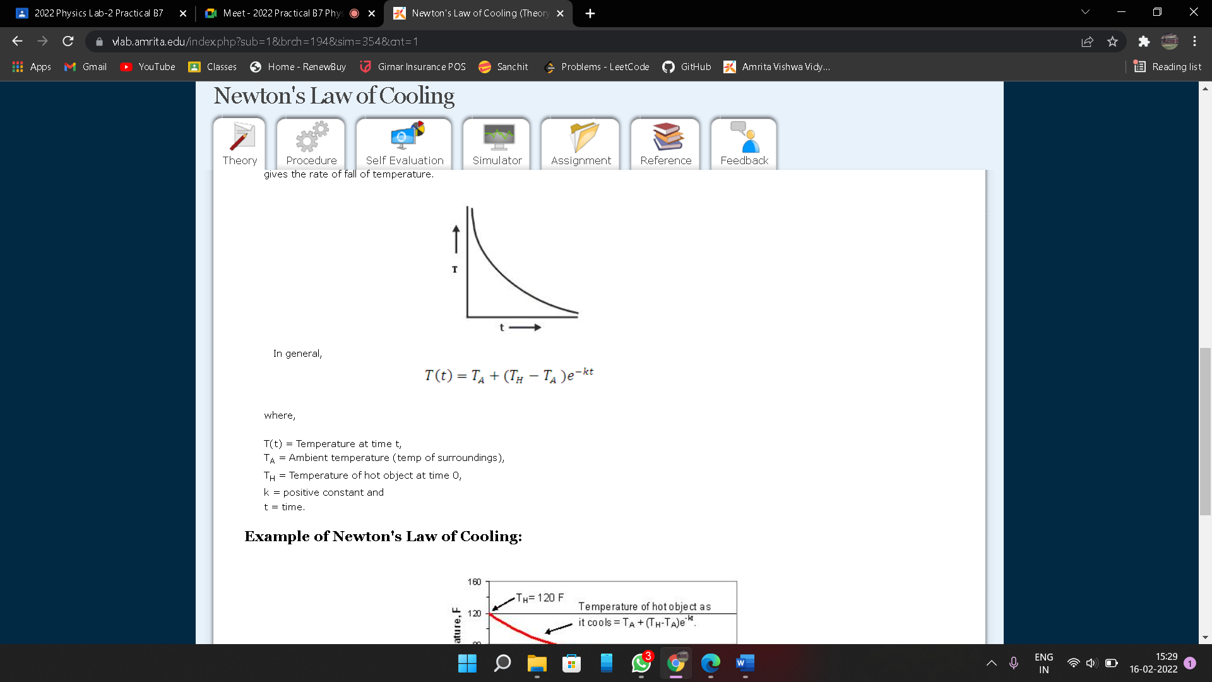

T(t)=Temperature at time t,

TA=Ambient temperature

TH=Temperature of hot object at time 0,

k=positive constant t=time.

**Observation Table:**

Material: Aluminium

Liquid: Water

|  |  |  |
| --- | --- | --- |
| S.NO. | TEMPERATURE(IN C) | TIME(IN M) |
| 1 | 95 | 0.95 |
| 2 | 90 | 1.98 |
| 3 | 85 | 3.19 |
| 4 | 80 | 4.21 |
| 5 | 75 | 5.63 |
| 6 | 70 | 7.10 |
| 7 | 65 | 8.89 |

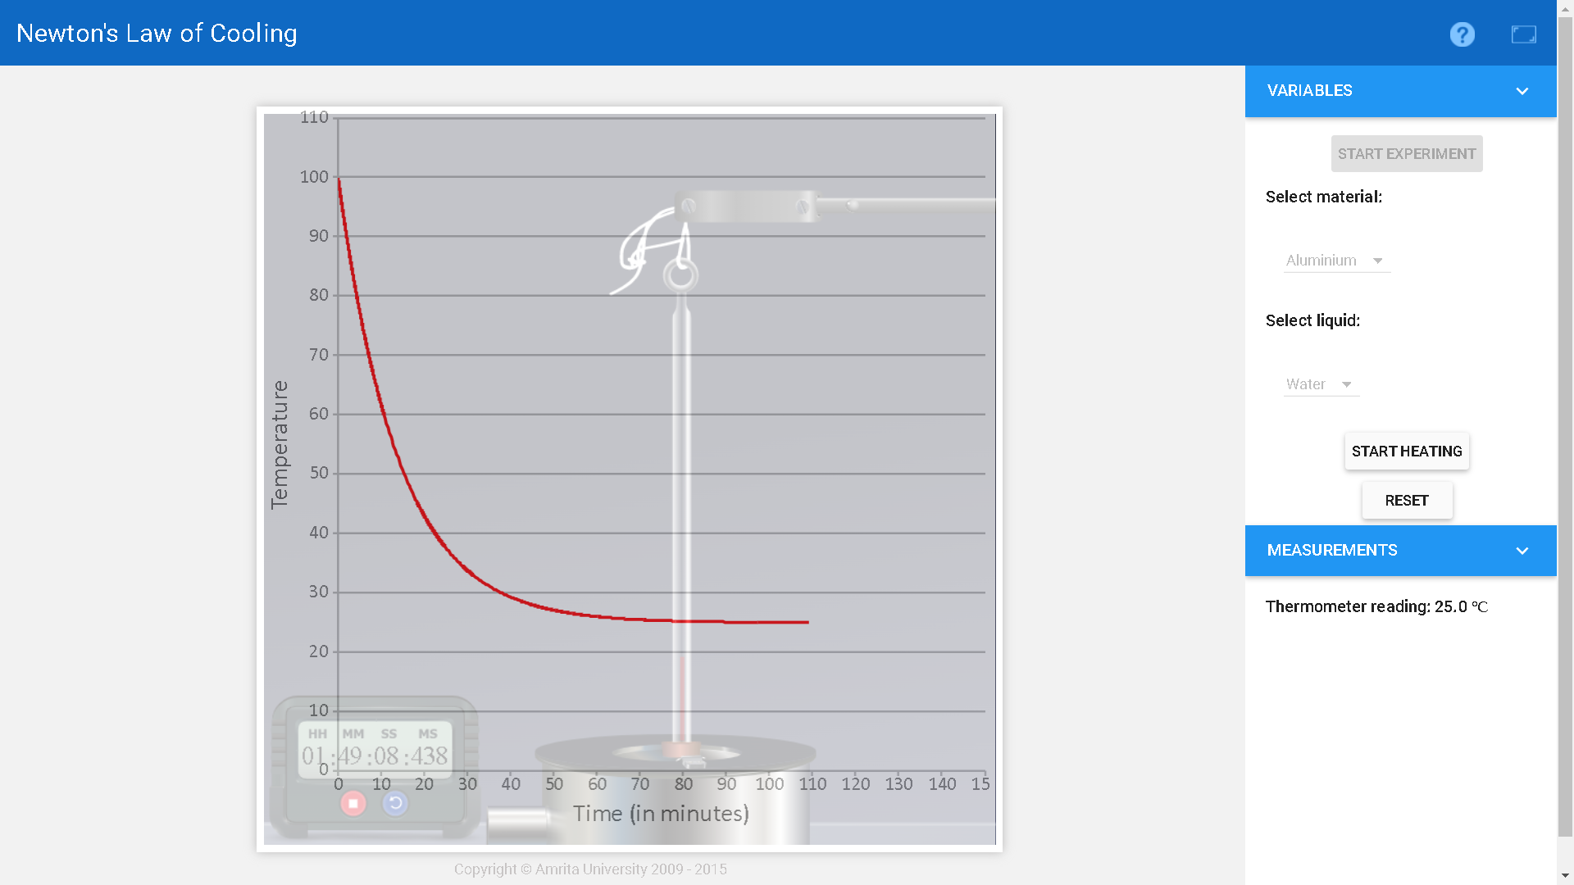

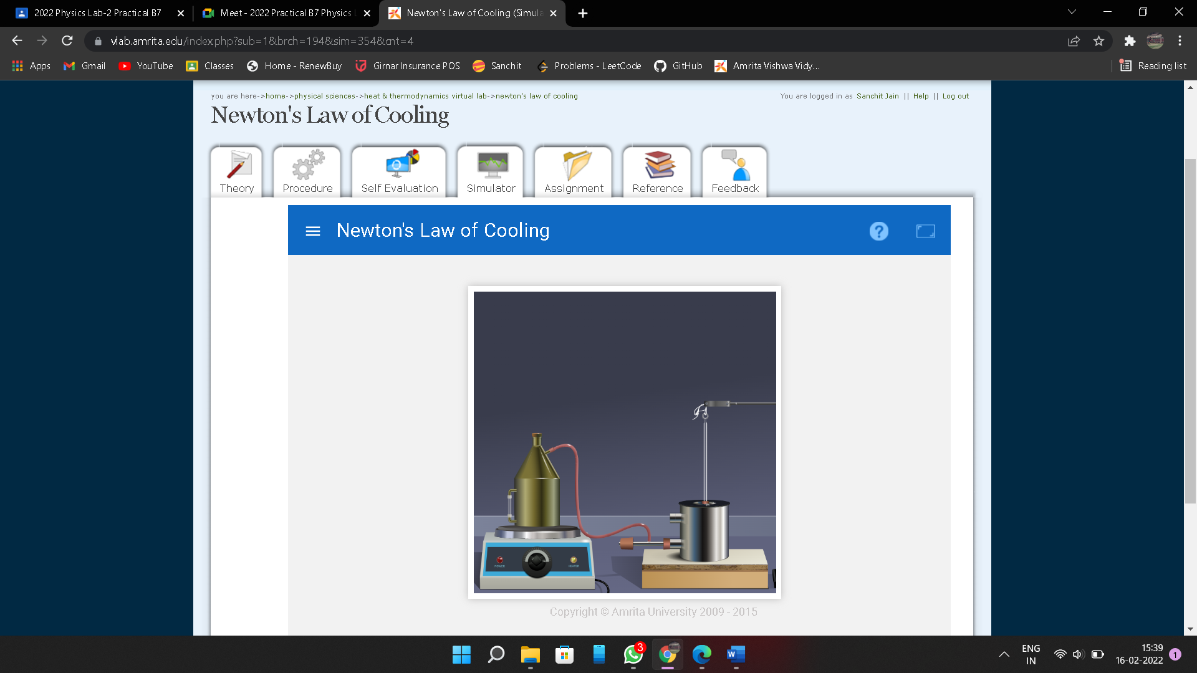

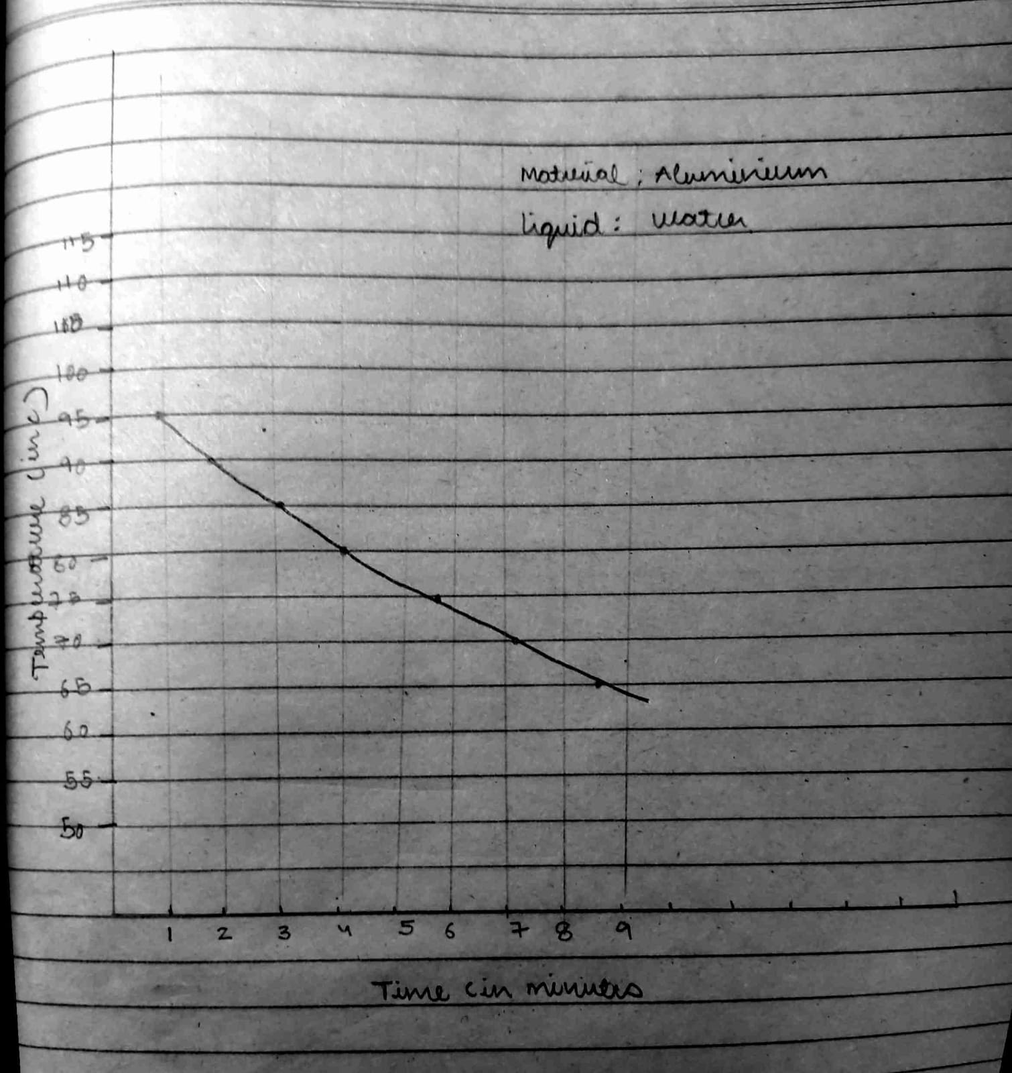

Material: Aluminium

Liquid: Milk

|  |  |  |
| --- | --- | --- |
| S.no | TEMPERATURE(IN C) | TIME(IN M) |
| 1 | 95 | 0.883 |
| 2 | 90 | 1.866 |
| 3 | 85 | 2.88 |
| 4 | 80 | 4.19 |
| 5 | 75 | 5.41 |
| 6 | 70 | 6.61 |
| 7 | 65 | 8.23 |

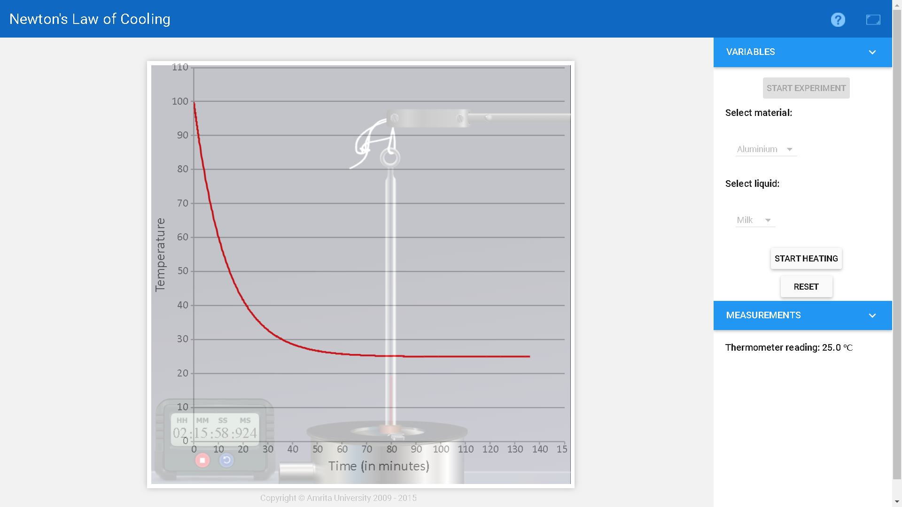

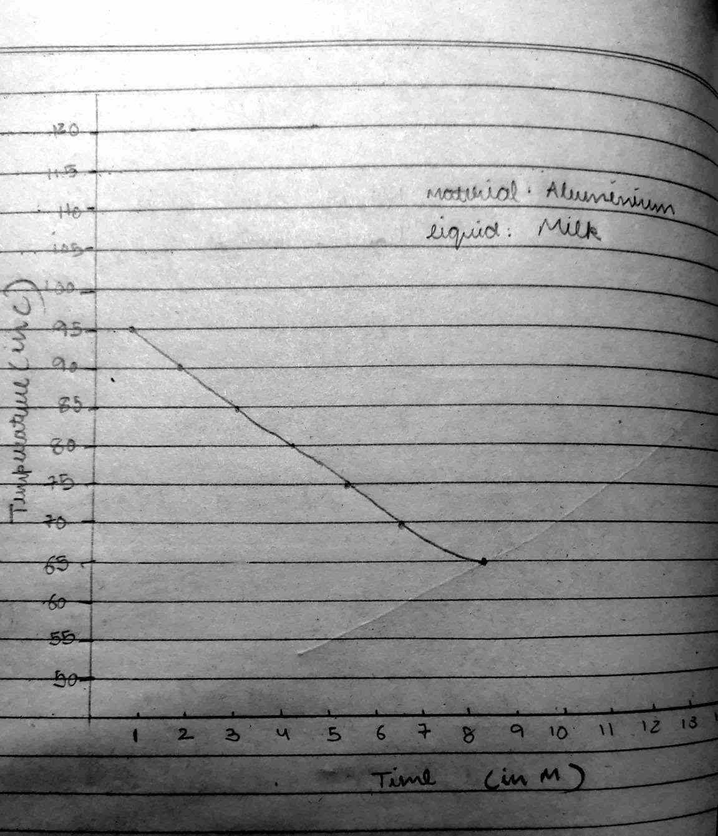

**Result:**

From the Equation, we can say that Temperature decreases exponentially with time from the observation of the e-kt term. The cooling curve of the liquid is plotted. The temperature falls quickly in the beginning and then slowly as the difference of temperature goes on decreasing and we obtain an exponentially decreasing graph from the experimental values.

Hence Newton‘s law of cooling is verified.